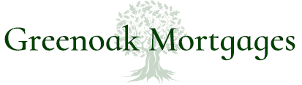
44 Broadway
Maidenhead
Berkshire
SL6 1LU
Phone: 01628 94434
Mobile: 07836344559
Email: nigel@greenoakmortgages.co.uk

Nigel Dennis, trading as Greenoak Mortgages is an appointed representative of HL Partnership Limited which is authorised and regulated by the Financial Conduct Authority.

